Table of Contents
Product Roadmap (Initial) 1
Product Backlog (Initial) 1
Solution Architecture (Initial) 6
Sprint Plan 7
Sprint Backlog 9
Burndown Chart 11
Sprint Review 13
Sprint Retrospective 15
DevSecOps Pipeline Design 16
Updated Roadmap 19
Updated Solution Architecture 20
Appendix 22

Product Roadmap (Initial)

AquaShield is an aquaculture decision-support platform designed to help farms, researchers, and aquaculture product businesses monitor pond conditions, evaluate treatment outcomes, and make data-backed operational decisions. Although the visible starting point of the product is water-quality monitoring, the platform is not limited to displaying sensor readings. Its broader purpose is to support aquaculture operations through pond-level digital twins, real-time water-quality tracking, energy and operational efficiency monitoring, pond-to-pond comparison, alerts, reporting, and treatment-effectiveness analysis. This is especially important for an aquaculture startup or product company because the business is not only selling a biological or treatment product; it also needs measurable evidence that the product improves pond conditions, reduces risk, lowers operating cost, or increases farming efficiency. To provide that evidence, AquaShield must collect reliable sensor data, organize it by project, pond, cycle, treatment, and profile type, and convert it into dashboards and analytics that different stakeholders can use.
The platform is designed around multiple user groups. Farmers and farm managers need a practical view of pond health, early warnings when parameters move outside safe ranges, comparison between ponds, and evidence of whether a treatment reduces problems such as excess nitrogen or unstable water conditions. Researchers and product developers need structured historical data, visual dashboards, comparison tools, and treatment-effectiveness records so they can evaluate whether their aquaculture product works under real farming conditions. Business owners and platform administrators need a scalable platform that can support different farm profiles, multiple projects, different users, configurable feature access, and consistent reporting across farm operations. This platform mindset changes AquaShield from a simple monitoring dashboard into a business tool for validating aquaculture products and improving farm operations.
The product roadmap begins with the operational platform foundation. The first roadmap area is user and access management so each stakeholder can use the platform according to their role. The second roadmap area is project, profile, pond, and cycle management so aquaculture data is organized around the real structure of farm work. The third roadmap area is sensor registration and water-quality monitoring so readings can be connected to the correct pond context. The fourth roadmap area is digital twin visualisation, historical charts, pond comparison, alerts, and notification workflows so users can understand both current pond status and historical operating patterns. The fifth roadmap area is treatment tracking and treatment-effectiveness reporting so the platform can support business evidence for aquaculture products. This roadmap keeps the Phase 0 scope focused on a practical product foundation: collect reliable pond data, organize it meaningfully, alert users when conditions change, and turn farm activity into evidence that farmers, researchers, and business owners can trust.

Product Backlog (Initial)

The AquaShield product backlog was organized around the main capabilities required for an aquaculture decision-support platform. The backlog focuses on the business and user needs of farmers, researchers, aquaculture product developers, business owners, and platform administrators. The user stories show how the platform supports daily pond operations, product-effectiveness validation, treatment tracking, alerting, reporting, and planned decision intelligence.
Product Backlog Epics and User Stories

1. Authentication and User Management
- As a platform user, I want to sign in and sign out securely so that my account and farm data are protected.
- As a platform user, I want to view and update my own profile so that my contact details and account information remain current.
- As a platform administrator, I want to onboard new users with appropriate access rights so that each user can start with the correct responsibilities.
- As a platform administrator, I want to deactivate a user without deleting history so that the platform preserves accountability and operational records.

2. Project and Profile Configuration
- As a platform administrator, I want to create projects and assign project owners so that the platform can support multiple farms, customers, or research sites.
- As a platform administrator, I want to define farm profile types such as shrimp, fish, crab hatchery, and product-specific profiles so that each project can follow the correct farming model.
- As a platform administrator, I want to configure water-quality parameters and safe ranges so that monitoring and alerts match the needs of each farm profile.
- As a business owner, I want configurable project and profile settings so that the platform can support different customers without redesigning the product for each farm.

3. Pond Operations
- As a farm manager, I want to view all ponds under a project so that I can understand the overall farm condition at a glance.
- As a farm manager, I want to view the current health status of each pond so that I can prioritize operational action.
- As a farm manager, I want to manage pond details such as location, image, profile, and operating status so that each pond is clearly identified.
- As a researcher, I want pond information to be connected with readings and treatments so that later analysis has the correct operational context.

4. Cycle and Growth Management
- As a farm manager, I want to start and manage a growth cycle for a pond so that readings and observations are linked to the correct farming period.
- As a farm manager, I want to record daily health observations so that the platform keeps a history of pond condition during each cycle.
- As a farm manager, I want to track cycle stages such as juvenile, grow-out, and pre-harvest so that the pond status reflects the real production stage.
- As a researcher, I want to review cycle-level health history so that product performance can be compared across different farming periods.

5. Sensor and Device Management
- As a system administrator, I want to register sensors and devices so that incoming readings are accepted only from known sources.
- As a system administrator, I want to assign sensors to projects and ponds so that each reading is connected to the correct farm context.
- As a system administrator, I want to activate or deactivate sensors without deleting them so that historical data remains traceable.
- As a platform operator, I want raw sensor messages to be retained so that abnormal readings can be investigated from the original source.

6. Water Monitoring and Digital Twin
- As a farmer, I want to view a digital twin of each pond so that water conditions are easier to understand visually.
- As a farmer, I want to see current water-quality readings so that I can react quickly when conditions start to become unsafe.
- As a farm manager, I want the platform to highlight abnormal pond conditions so that I can decide which pond needs immediate attention.
- As a researcher, I want live readings to be organized by pond, cycle, and profile so that the data can support analysis and product validation.

7. Visualisation and Historical Trends
- As a farmer, I want to view water-quality trends over time so that I can understand whether a pond is improving or deteriorating.
- As a researcher, I want to analyze historical readings by parameter and date range so that I can study the effect of different treatments and conditions.
- As a business owner, I want clear charts and dashboards so that product results can be explained to customers and stakeholders.
- As a platform user, I want to export filtered historical data so that information can be shared for reporting, research, or advisory purposes.

8. Pond Comparison
- As a farm manager, I want to compare multiple ponds side by side so that I can identify which pond is performing better.
- As a researcher, I want to compare parameter trends between ponds so that treatment or operating differences can be evaluated.
- As a business owner, I want pond comparison results so that product-effectiveness claims can be supported with visual evidence.
- As a farmer, I want comparison results over a selected date range so that I can make decisions using the period that matters to my operation.

9. Alerts and Notifications

- As a farmer, I want to receive alerts when a water-quality parameter crosses its safe threshold so that I can respond before stock health is affected.
- As a farm manager, I want alerts to show severity and affected pond information so that I can prioritize the response.
- As a farm manager, I want to acknowledge alerts so that the team knows when an issue is being handled.
- As a platform administrator, I want alert history to be retained so that operational incidents can be reviewed later.

10. Treatment Management
- As a farmer, I want to record treatments applied to a pond so that the platform tracks what was done and when.
- As a researcher, I want to compare pre-treatment and post-treatment readings so that I can evaluate treatment effectiveness.
- As a product developer, I want to measure outcomes such as nitrogen reduction, water stability, and recovery time so that product performance can be validated.
- As a business owner, I want treatment-effectiveness summaries so that the product value can be communicated to customers and partners.

11. Security, Audit, and Compliance
- As a platform user, I want my account and project data to be protected so that sensitive farm and business information is not exposed.
- As a platform administrator, I want user actions and important changes to be logged so that accountability is maintained.
- As a farm manager, I want alert acknowledgements and treatment records to be traceable so that operational decisions can be reviewed.
- As a business owner, I want reliable audit evidence so that platform reports can be trusted by customers, researchers, and partners.

12. ML Prediction and Agentic Decision Support
- As a farmer, I want the platform to predict upcoming water-quality conditions so that I can prepare before pond parameters become unsafe.
- As a researcher, I want the prediction model to use historical pond readings, cycles, treatments, and profile context so that forecasts are based on meaningful aquaculture data.
- As a product developer, I want unusual sensor patterns and treatment outcomes to be highlighted so that product performance and pond risk can be studied more effectively.
- As a farmer, I want an assistant to explain critical alerts in simple operational language so that I can understand what happened and what should be checked first.
- As a researcher or business owner, I want a report assistant that summarizes pond performance, treatment evidence, and comparison results so that findings can be communicated clearly.
- As a platform user, I want any recommended action to remain human-reviewed so that the system supports decision-making without replacing expert judgement.

Architectural Constraints

The user stories created architectural constraints that had to be considered from the beginning of the platform design. These constraints focus on product behavior, data responsibility, security, reliability, and planned growth rather than on a single implementation choice.
No. | Architectural Constraint | Why It Matters | Design Implication
1 | Multi-stakeholder usage | Farmers, researchers, product developers, business owners, and administrators require different views and permissions. | The platform must support role-based access, project ownership, and configurable feature visibility.
2 | Multi-project and multi-farm support | The same product must support different customers, farms, ponds, and aquaculture profiles. | Data must be organized by project, pond, profile, cycle, and user responsibility.
3 | Real-time operational awareness | Water-quality problems can affect stock quickly, so users need timely information and alerts. | Sensor readings, dashboard updates, and alert decisions must be handled with low delay.
4 | Flexible aquaculture profiles | Different farm types and products may require different parameters, thresholds, and lifecycle stages. | Profile, parameter, threshold, and stage configuration must be adaptable.
5 | Treatment-effectiveness evidence | The business needs measurable proof that the product improves pond conditions and operational outcomes. | Treatments must be linked to sensor readings, pond cycles, comparisons, and reports.
6 | High-volume historical readings | Continuous monitoring produces more data than normal user and project records. | Current readings, historical trends, and summary analytics must be organized for long-term use.
7 | Traceability and auditability | Sensor messages, alerts, treatments, and user decisions must be explainable after the event. | Important actions and data changes must have history, timestamps, and clear ownership.
8 | Secure human and device access | Both people and field devices can affect the trustworthiness of platform data. | Users and devices must be verified before they can access, publish, or modify information.
9 | Reliable farm operations | Farmers should not depend on manual checking alone when pond risk increases. | Monitoring, alerting, and dashboard workflows must remain dependable during normal operation.
10 | ML and Agentic capability | Water-quality prediction and assistant-based explanation require reliable historical readings, treatment records, alerts, and reports. | The platform must preserve clean historical data and clear context so planned prediction and decision-support features can be added safely.

Solution Architecture (Initial)

Logical Architecture
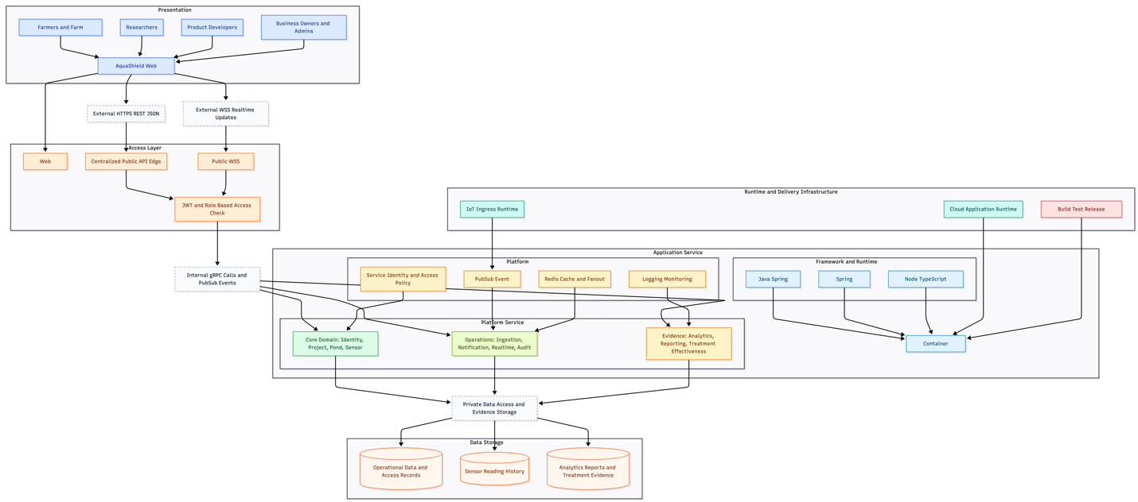

Physical Architecture

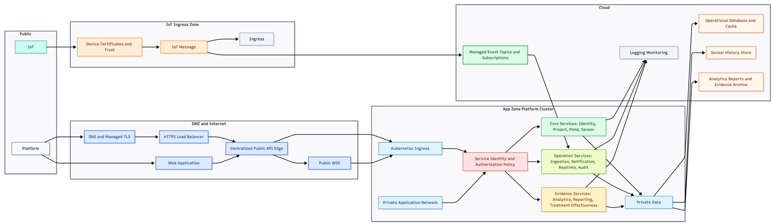

Deployment Diagram

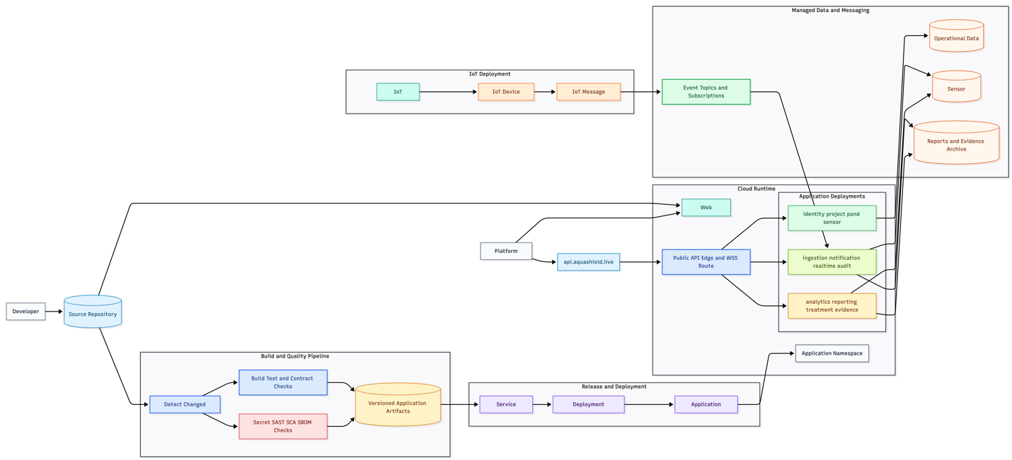

Sprint Plan

The sprint plan organizes AquaShield as a sequence of one-week product increments. The earlier sprints focus on product understanding, design, core platform capability, monitoring, comparison, alerts, treatment records, quality, and deployment readiness. The planned later sprints extend the platform with ML-based water-quality prediction and four agentic decision-support use cases.

Sprint | Duration | Sprint Focus | Status | Planned Outcome
Sprint 1 | 1 week | Product discovery and platform direction | Completed | Confirm the product objective, target users, main business value, and initial scope.
Sprint 2 | 1 week | Product backlog and use-case design | Completed | Define major epics, user stories, use cases, and key platform constraints.
Sprint 3 | 1 week | Data and domain design | Completed | Define the main business entities, relationships, pond context, cycle context, sensor context, and treatment context.
Sprint 4 | 1 week | Architecture and software design | Completed | Define the solution structure, major platform responsibilities, interaction flow, and critical design decisions.
Sprint 5 | 1 week | User, project, profile, and pond foundation | Completed | Implement the core management flow for users, projects, farm profiles, ponds, parameters, and threshold setup.
Sprint 6 | 1 week | Monitoring, digital twin, visualisation, and treatment records | Completed | Provide pond monitoring, current readings, historical visualisation, and treatment record foundation.
Sprint 7 | 1 week | Alerts, notification flow, and traceability | Completed | Add threshold-based alerts, acknowledgement flow, notification readiness, and operational history.
Sprint 8 | 1 week | Pond comparison and reporting | Completed | Provide comparison between ponds, summary views, and evidence-style reporting for researchers and business users.
Sprint 9 | 1 week | Quality, security, deployment, and presentation evidence | Completed | Validate the platform, prepare review evidence, and demonstrate that the product increment can be operated professionally.
Sprint 10 | 1 week | ML water-quality prediction | Planned | Build a prediction workflow for upcoming pond water-quality conditions using historical readings, cycles, treatments, and profile context.
Sprint 11 | 1 week | Agentic alert explanation | Planned | Explain critical pond alerts in simple operational language so users understand what happened and what to check first.
Sprint 12 | 1 week | Agentic report assistant | Planned | Summarize pond performance, treatment evidence, and comparison results for farmers, researchers, and business owners.
Sprint 13 | 1 week | Agentic grounded Q&A | Planned | Answer user questions using available project records, pond records, treatment notes, and platform reports.
Sprint 14 | 1 week | Agentic human-reviewed recommendation | Planned | Generate operator-facing recommendations that remain subject to human review before action is taken.

Sprint Backlog

The sprint backlog breaks the product backlog into one-week increments. Completed sprints are listed with their main backlog items and expected outcomes. Planned ML and agentic sprints are included as upcoming backlog items, but they are not counted as completed work.
Sprint | Backlog Items | Status | Expected Result
Sprint 1 | Product objective, target users, business problem, platform scope | Completed | The product direction is clear: AquaShield supports aquaculture monitoring, treatment evidence, and operational decision-making.
Sprint 2 | Epics, user stories, use cases, architecture constraints | Completed | The product backlog is organized around farmers, researchers, product owners, business users, and administrators.
Sprint 3 | Data ownership, project structure, pond structure, cycle structure, sensor-reading context, treatment context | Completed | The platform has a clear domain model for aquaculture operations and evidence tracking.
Sprint 4 | Software design for critical user stories, interaction flow, platform responsibility boundaries | Completed | The solution design explains how core user stories are supported across the platform.
Sprint 5 | Secure access, user profile, project creation, profile setup, pond setup, parameter threshold setup | Completed | Users can manage the core farm and project foundation needed for monitoring.
Sprint 6 | Current water-quality dashboard, digital twin view, historical visualisation, treatment record capture | Completed | Farmers and researchers can observe pond conditions and begin connecting treatments with readings.
Sprint 7 | Alert generation, alert acknowledgement, notification readiness, traceability records | Completed | Unsafe readings can trigger action, and operational responses can be retained for review.
Sprint 8 | Pond comparison, summary views, reporting views, treatment-effectiveness comparison | Completed | Users can compare ponds and evaluate operational or product-effectiveness evidence.
Sprint 9 | Test cases, review preparation, security checks, deployment readiness, presentation evidence | Completed | The completed increment can be validated, demonstrated, and explained in a professional report.
Sprint 10 | ML water-quality prediction | Planned | Predict upcoming water-quality conditions using historical pond readings, cycles, treatments, and profile context.
Sprint 11 | Agentic alert explanation | Planned | Explain critical alerts in user-friendly operational language.
Sprint 12 | Agentic report assistant | Planned | Summarize pond performance, treatment evidence, and comparison results.
Sprint 13 | Agentic grounded Q&A | Planned | Answer questions using available project, pond, treatment, and report records.
Sprint 14 | Agentic human-reviewed recommendation | Planned | Suggest operational actions while keeping final judgement under human control.

Sprint Backlog Summary

The completed sprint backlog establishes the product foundation before adding intelligence features. The first nine sprints cover product definition, backlog design, data design, platform design, user/project/pond management, monitoring, treatment records, alerts, comparison, reporting, quality checks, and review evidence. Sprint 10 introduces ML prediction after the historical data foundation exists. Sprints 11 to 14 split the agentic work into four clear use cases: alert explanation, report assistant, grounded Q&A, and human-reviewed recommendation.

Burndown Chart

The burndown chart is organized per one-week sprint. Completed sprints include starting backlog, completed items, and remaining items. The ML and agentic sprints are listed in the same chart, but their burndown values are intentionally left blank because those sprints have not been executed yet.
Sprint | Sprint Focus | Starting Backlog Items | Completed Items | Remaining Items | Status
Sprint 1 | Product discovery and platform direction | 4 | 4 | 0 | Completed
Sprint 2 | Product backlog and use-case design | 4 | 4 | 0 | Completed
Sprint 3 | Data and domain design | 6 | 6 | 0 | Completed
Sprint 4 | Architecture and software design | 4 | 4 | 0 | Completed
print 5 | User, project, profile, and pond foundation | 6 | 6 | 0 | Completed
Sprint 6 | Monitoring, digital twin, visualisation, and treatment records | 4 | 4 | 0 | Completed
Sprint 7 | Alerts, notification flow, and traceability | 4 | 4 | 0 | Completed
Sprint 8 | Pond comparison and reporting | 4 | 4 | 0 | Completed
Sprint 9 | Quality, security, deployment, and presentation evidence | 5 | 5 | 0 | Completed
Sprint 10 | ML water-quality prediction |  |  |  | Planned
Sprint 11 | Agentic alert explanation |  |  |  | Planned
Sprint 12 | Agentic report assistant |  |  |  | Planned
Sprint 13 | Agentic grounded Q&A |  |  |  | Planned
Sprint 14 | Agentic human-reviewed recommendation |  |  |  | Planned

Burndown Interpretation

The completed sprints show that the current product foundation has been closed for review. The blank values for Sprint 10 to Sprint 14 show that the ML and agentic increments are still planned and should receive their own burndown updates when those one-week sprints are carried out.

Sprint Review

The sprint review summarizes the completed work from Sprint 1 to Sprint 9. It does not review Sprint 10 to Sprint 14 because the ML and agentic increments have not been executed yet.

Sprint | Review Area | Review Outcome
Sprint 1 | Product discovery and platform direction | The product objective, stakeholders, business value, and platform scope were clarified.
Sprint 2 | Product backlog and use-case design | The backlog was organized into epics and user stories for aquaculture monitoring, treatment evidence, alerts, reporting, and decision support.
Sprint 3 | Data and domain design | The main project, pond, cycle, sensor, reading, treatment, alert, and reporting concepts were defined.
Sprint 4 | Architecture and software design | The solution design and critical user-story flow were clarified.
Sprint 5 | User, project, profile, and pond foundation | The core setup flow for users, projects, profiles, ponds, parameters, and thresholds was completed.
Sprint 6 | Monitoring, digital twin, visualisation, and treatment records | Users can observe pond conditions, view historical trends, and capture treatment records.
Sprint 7 | Alerts, notification flow, and traceability | Unsafe readings can be surfaced as alerts, responses can be acknowledged, and operational history can be retained.
Sprint 8 | Pond comparison and reporting | Users can compare ponds and review evidence for operational and product-effectiveness decisions.
Sprint 9 | Quality, security, deployment, and presentation evidence | The completed increment was validated and prepared for demonstration and reporting.

Review Summary

The completed sprints produced a coherent AquaShield platform foundation. The work supports farmers by improving pond visibility and response to water-quality risk, supports researchers by organizing historical data and treatment evidence, and supports business owners by turning product performance into measurable reporting. The planned ML and agentic sprints are not included in this review and should be reviewed separately after completion.

Sprint Retrospective

The sprint retrospective covers the completed work from Sprint 1 to Sprint 9. It does not evaluate the planned ML and agentic sprints because those increments have not been carried out yet.
No. | Area | Observation | Improvement Action
1 | Product understanding | The platform value became clearer when water monitoring was connected to treatment-effectiveness and business evidence. | Continue writing requirements from the viewpoint of farmers, researchers, product owners, and business owners.
2 | Backlog structure | Grouping the work by epics helped separate daily farm operations, research analysis, business reporting, and platform administration. | Keep backlog items tied to clear user roles and measurable outcomes.
3 | Scope control | AquaShield has many possible capabilities, so completed sprints needed clear boundaries. | Keep each sprint focused on one coherent product increment.
4 | Domain clarity | Several features depended on the relationship between project, pond, cycle, sensor reading, treatment, and alert records. | Define data relationships and acceptance criteria before starting complex workflow items.
5 | User experience | Farmers need quick operational understanding, while researchers and business owners need detailed evidence. | Separate operational dashboard needs from analytical and reporting needs.
6 | Treatment evidence | Treatment-effectiveness tracking is central to the business case but requires accurate before-and-after data. | Make treatment timestamps, related readings, and comparison rules explicit in upcoming backlog items.
7 | Alert workflow | Alert generation alone is not enough; acknowledgement and history are needed for operational accountability. | Include response tracking and incident review in alert-related stories.
8 | Trust and reporting | Platform reports are only useful if the underlying data can be trusted and traced. | Continue treating traceability, audit history, and testing as part of the product rather than as optional finishing work.

Retrospective Conclusion

The main lesson from the completed sprints is that AquaShield should be treated as an aquaculture decision-support platform rather than only a water-monitoring application. The strongest product value comes from connecting water-quality data with pond operations, treatment records, comparison, alerts, and business evidence. The planned ML and agentic sprints should build on this foundation and should receive their own review and retrospective after they are completed.

DevSecOps Pipeline Design

The AquaShield DevSecOps pipeline is designed to make every platform change traceable, testable, secure, and deployable. The pipeline combines continuous integration, security validation, container release, GitOps handoff, and deployment reconciliation. This supports the project goal of delivering AquaShield as a professional aquaculture platform rather than only as a working application.
Continuous Integration and Security Pipeline

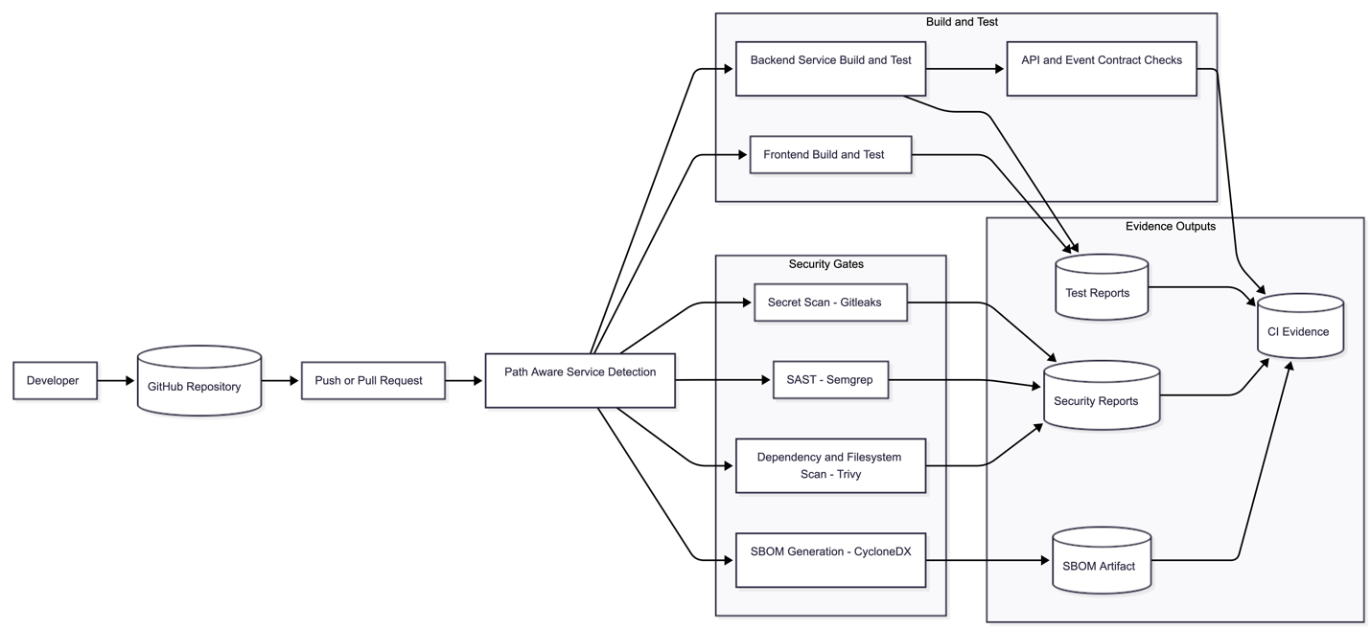
Continuous Delivery and GitOps Pipeline

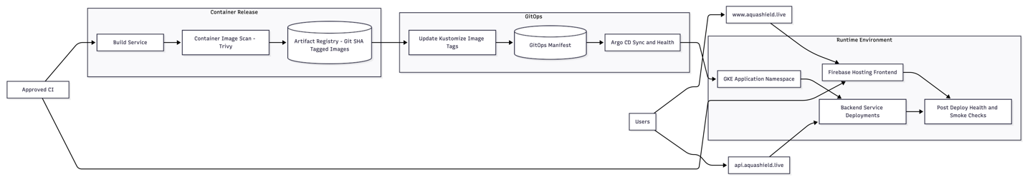

Pipeline Stages

No. | Stage | Purpose | Output
1 | Source control trigger | Start the pipeline when a change is pushed or reviewed. | Traceable commit and workflow run.
2 | Changed-service detection | Identify which services are affected by the change. | Path-aware build and test scope.
3 | Build and test | Validate frontend and backend behavior before release. | Test results and build evidence.
4 | Contract validation | Check that API and event contracts remain consistent. | Contract compatibility evidence.
5 | Secret scanning | Prevent leaked credentials from entering the repository history. | Secret scan report.
6 | Static security scan | Detect risky source-code patterns before deployment. | SAST report.
7 | Dependency and filesystem scan | Identify vulnerable dependencies and configuration risks. | Dependency and filesystem security report.
8 | SBOM generation | Produce a software bill of materials for supply-chain visibility. | CycloneDX SBOM artifact.
9 | Container build and image scan | Package services and scan images before release. | Scanned service images.
10 | Artifact Registry push | Store versioned images with Git-SHA tags. | Traceable image artifact.
11 | GitOps manifest update | Update deployment manifests with the approved image tag. | Kustomize manifest commit.
12 | Argo CD rollout | Reconcile the runtime environment with the GitOps source of truth. | Synced and healthy deployment state.
13 | Post-deploy validation | Confirm the deployed platform is reachable and operational. | Health or smoke-test evidence.

Design Rationale

The pipeline separates CI, security, release, and deployment responsibilities. CI validates code and produces evidence. Security gates run before the container image is promoted. The release stage pushes immutable, Git-SHA-tagged images to the image registry. The GitOps stage updates the deployment source of truth instead of changing the cluster manually. Argo CD then applies the desired state to the runtime environment and provides rollout visibility.
This design also supports path-aware delivery. A change to one backend service can trigger build, test, scan, image release, and deployment handoff for that service without requiring the whole platform to be rebuilt unnecessarily. At the same time, repository-wide security checks such as secret scanning, SAST, dependency scanning, and SBOM generation provide consistent DevSecOps control across the platform.

Updated Roadmap

Stage | Roadmap Area | Status | Product Outcome
1 | Product discovery and platform direction | Completed | The platform objective, user groups, business value, and product scope are clarified.
2 | Product backlog and use-case design | Completed | The backlog is organized around farmers, researchers, product developers, business owners, and administrators.
3 | Project, profile, and pond foundation | Completed | The platform can represent farms, projects, profiles, ponds, cycles, parameters, and thresholds.
4 | Sensor and monitoring foundation | Completed | Pond readings can be connected to the correct farm context and used for monitoring.
5 | Digital twin and historical visualisation | Completed | Users can observe pond status and review parameter trends over time.
6 | Pond comparison and reporting | Completed | Users can compare pond performance and prepare evidence for farm operations and product evaluation.
7 | Alerts, acknowledgement, and traceability | Completed | Unsafe readings can be surfaced, acknowledged, and retained as operational history.
8 | Treatment-effectiveness foundation | Completed | Treatment records can be connected with pond context and water-quality readings.
9 | Quality, security, and delivery evidence | Completed | The platform increment can be validated, demonstrated, and presented professionally.
0 | ML water-quality prediction | Planned | The platform predicts upcoming pond water-quality conditions using historical readings, cycles, treatments, and profile context.
11 | Agentic alert explanation | Planned | The assistant explains critical pond alerts in simple operational language.
12 | Agentic report assistant | Planned | The assistant summarizes pond performance, treatment evidence, and comparison results.
13 | Agentic grounded Q&A | Planned | The assistant answers questions using available project, pond, treatment, and report records.
14 | Agentic human-reviewed recommendation | Planned | The assistant proposes operational actions while keeping final judgement under human control.

Roadmap Rationale

The completed roadmap stages establish the information foundation needed for advanced decision support. Farmers need reliable monitoring and alerting before they can trust predictions. Researchers and product developers need historical readings, treatment records, and comparison results before they can evaluate product performance. Business owners need reports and traceable evidence before the platform can support customer-facing product claims.
For that reason, the Phase 1 roadmap adds ML and Agentic capability as product extensions, not as replacements for the monitoring platform. ML prediction uses the structured platform records to estimate upcoming water-quality conditions. Agentic Decision Support uses the same trusted records to explain alerts, summarize evidence, answer platform questions, and propose actions for human review. This keeps the product direction practical: AquaShield first captures and organizes aquaculture data, then uses that data to support prediction, explanation, reporting, and human-reviewed operational decisions.

Updated Solution Architecture

Logical Architecture

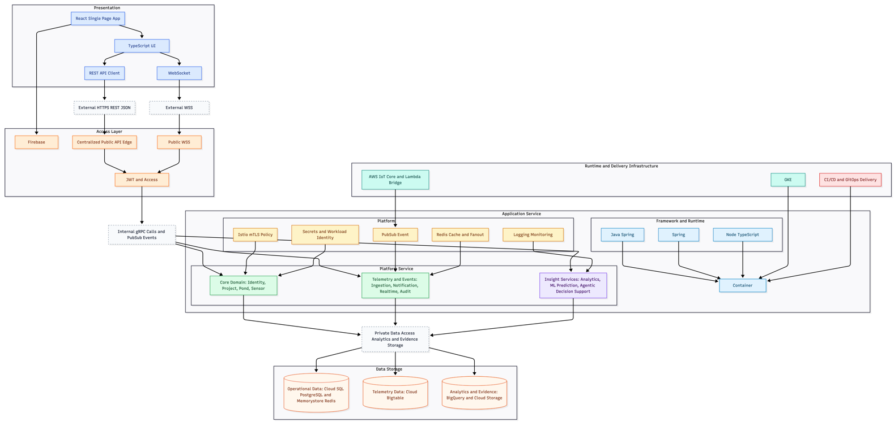

Physical Architecture

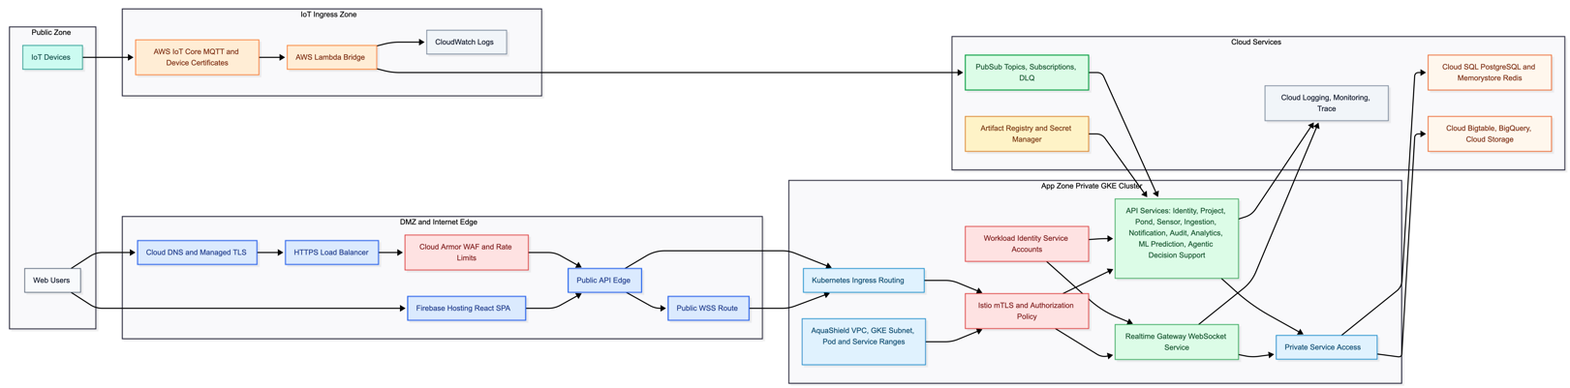

Deployment Diagram

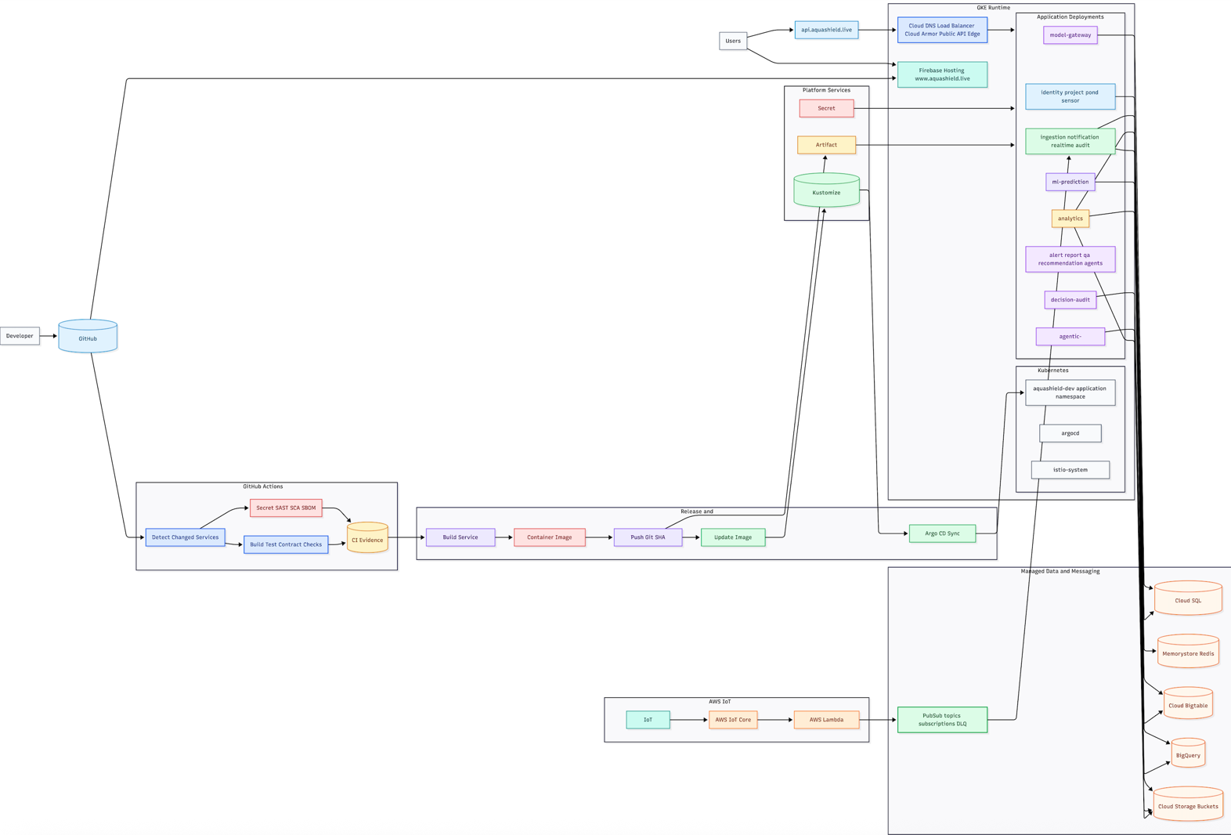

Appendix

GKE Cluster Health and Node Capacity Overview

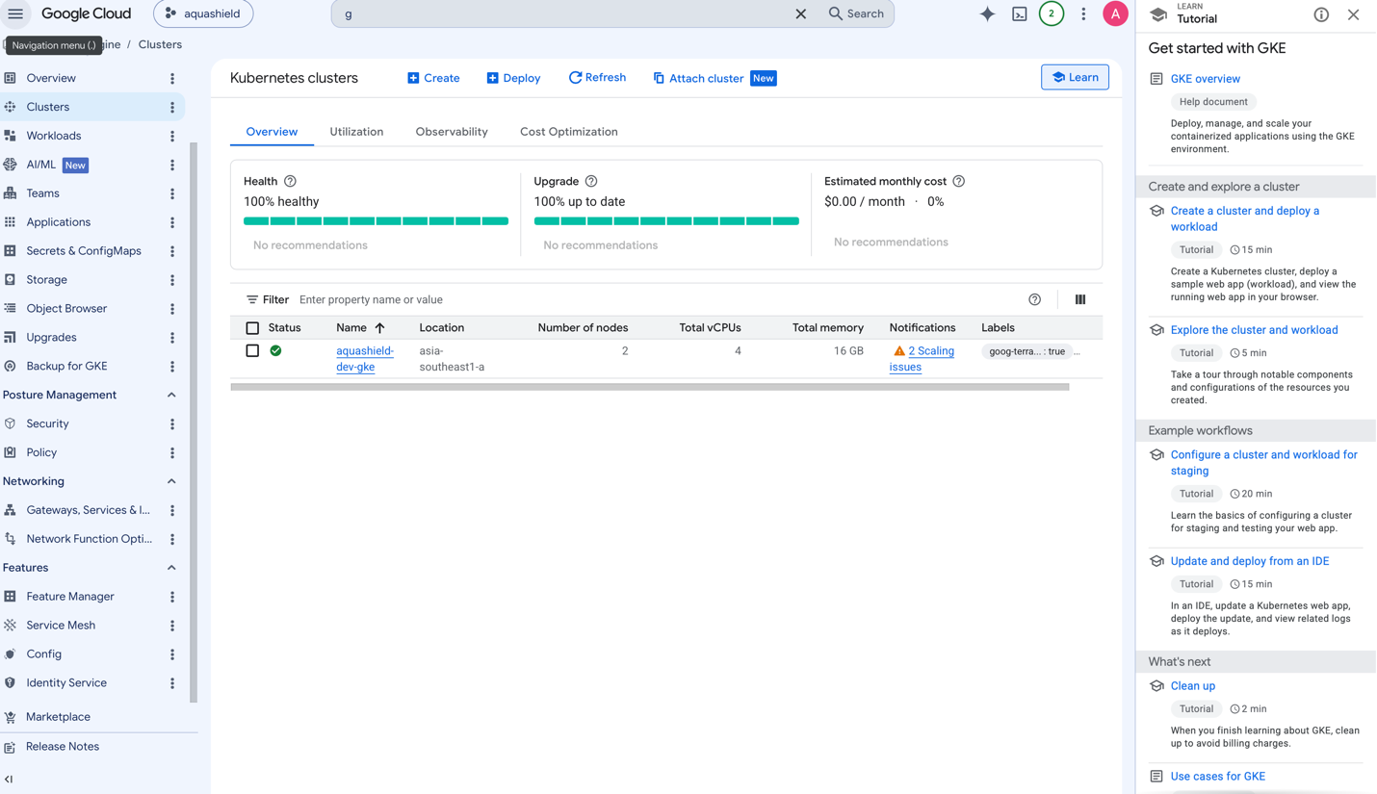

GKE Workloads Running Across AquaShield Services

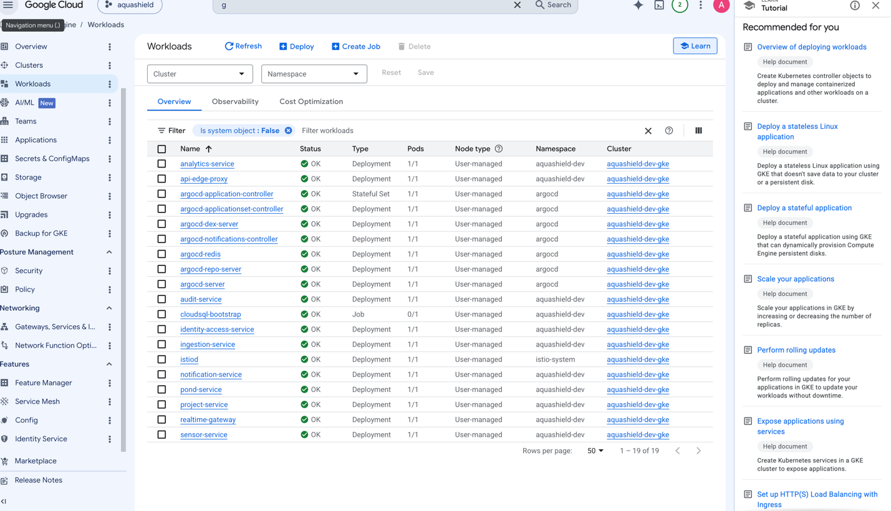

Public API Gateway Listener and Route Configuration

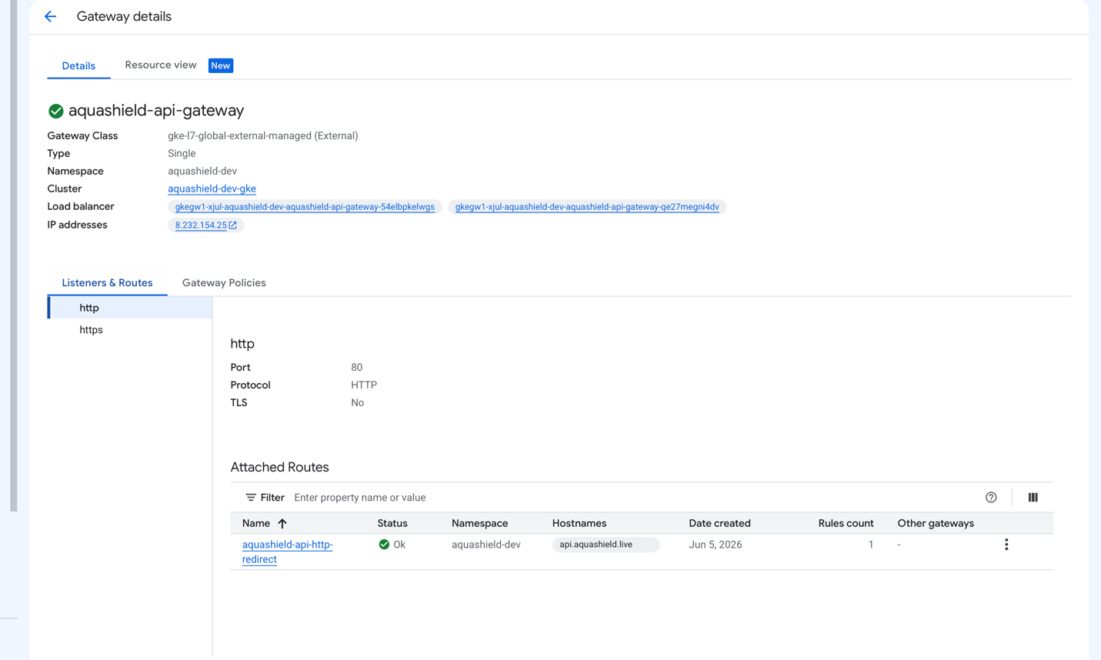

Kubernetes ConfigMaps and Secrets for Platform Runtime Configuration

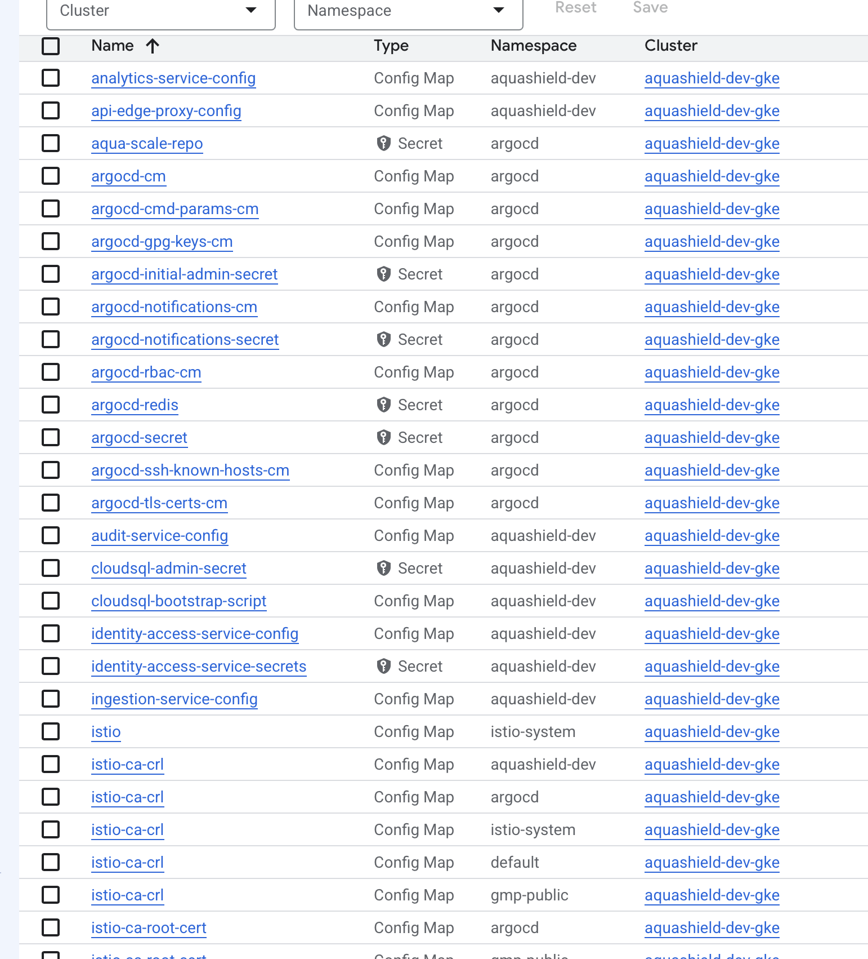

Artifact Registry Repositories for AquaShield Service Images

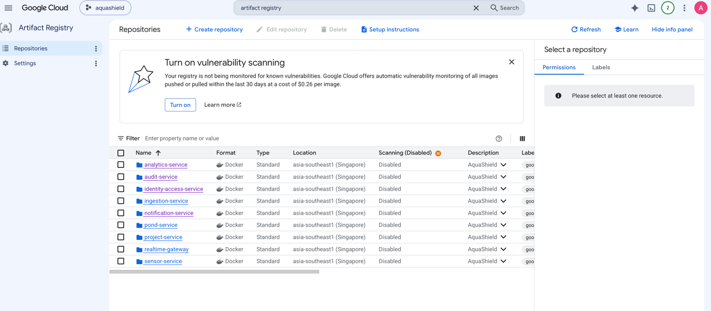

Backend CI Pipeline for All Changed Services

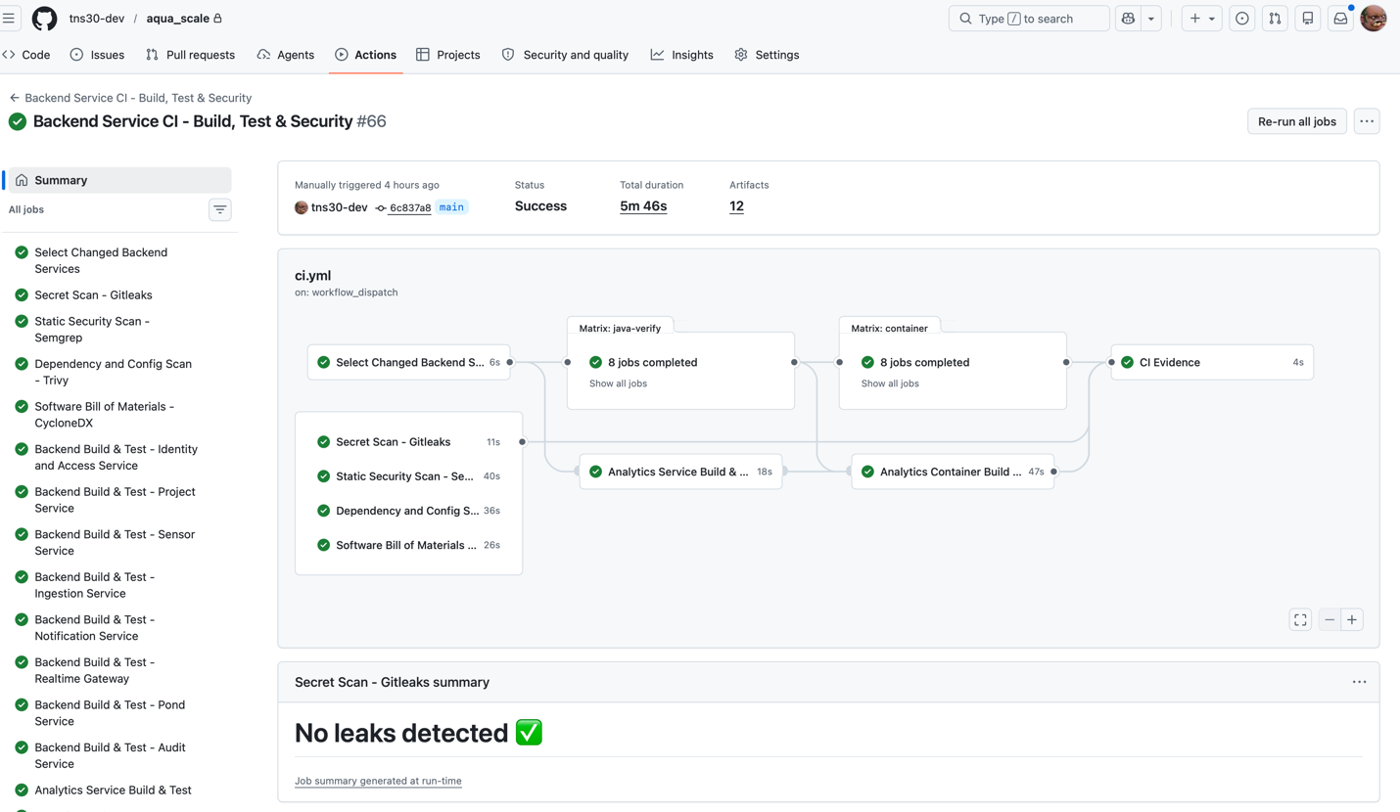

Backend CI Pipeline for Single-Service Change

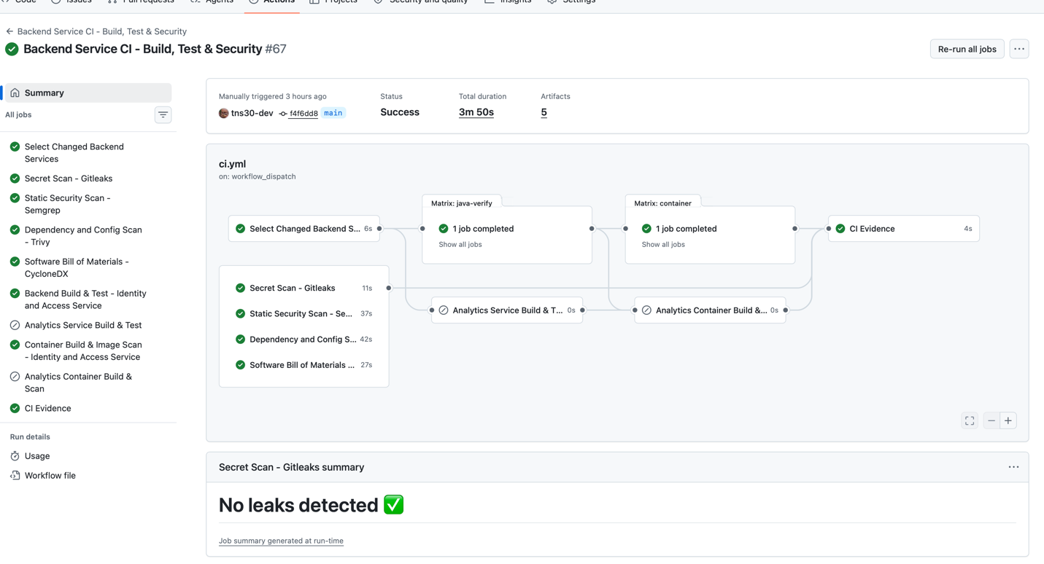

Container Release and Argo CD Handoff Pipeline

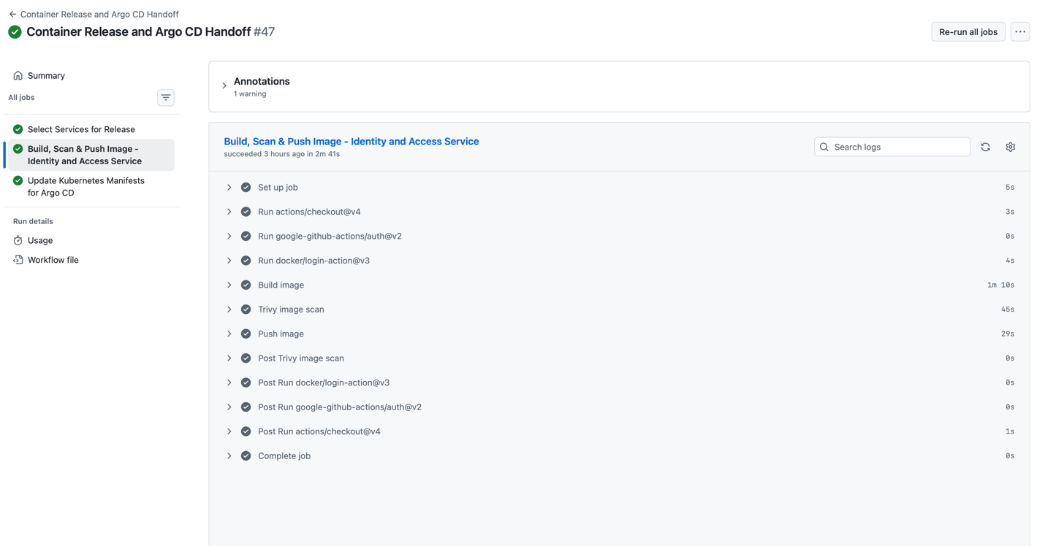

Pub/Sub Topics for Event-Driven Messaging

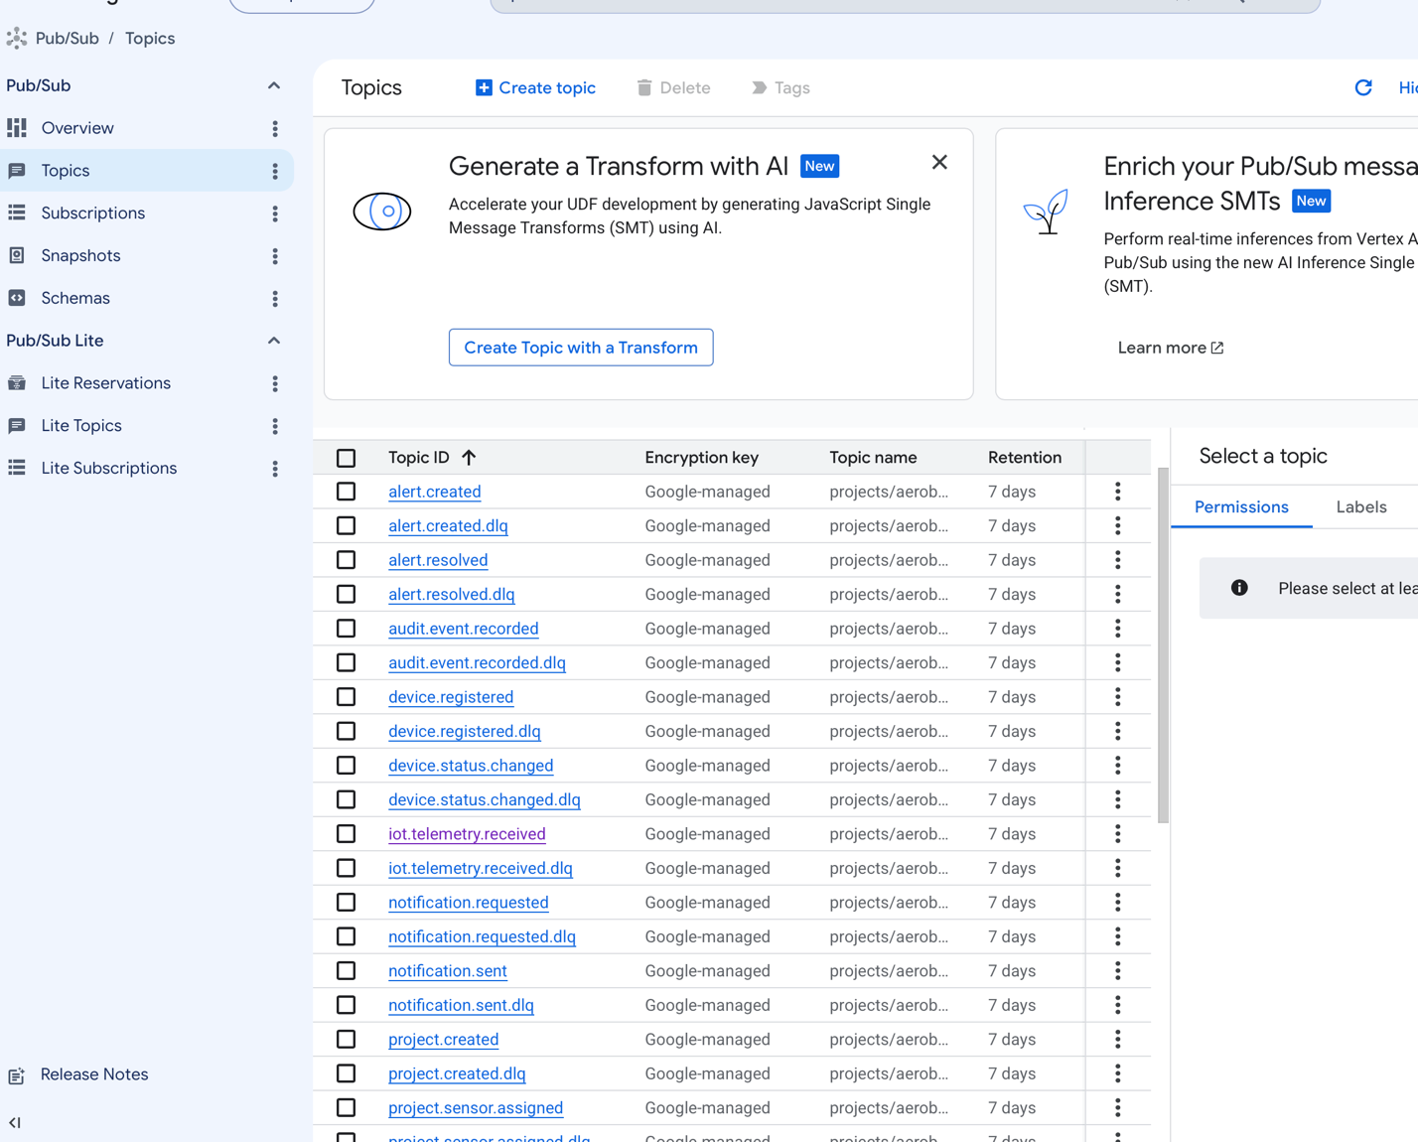

BigQuery Analytics Dataset and Alerts Table Schema

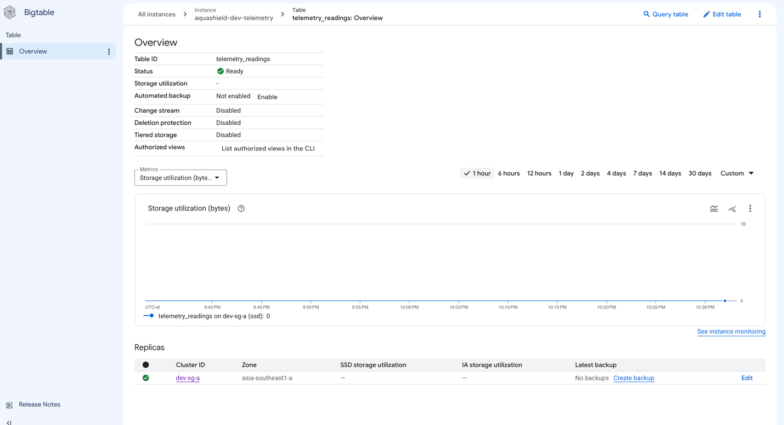

Bigtable Telemetry Readings Table Overview

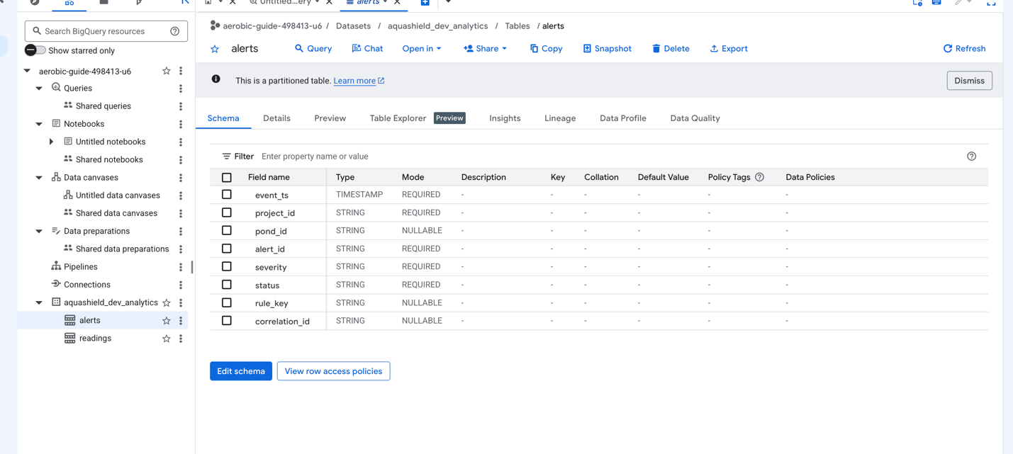

VPC Firewall Policies for GKE Network Security

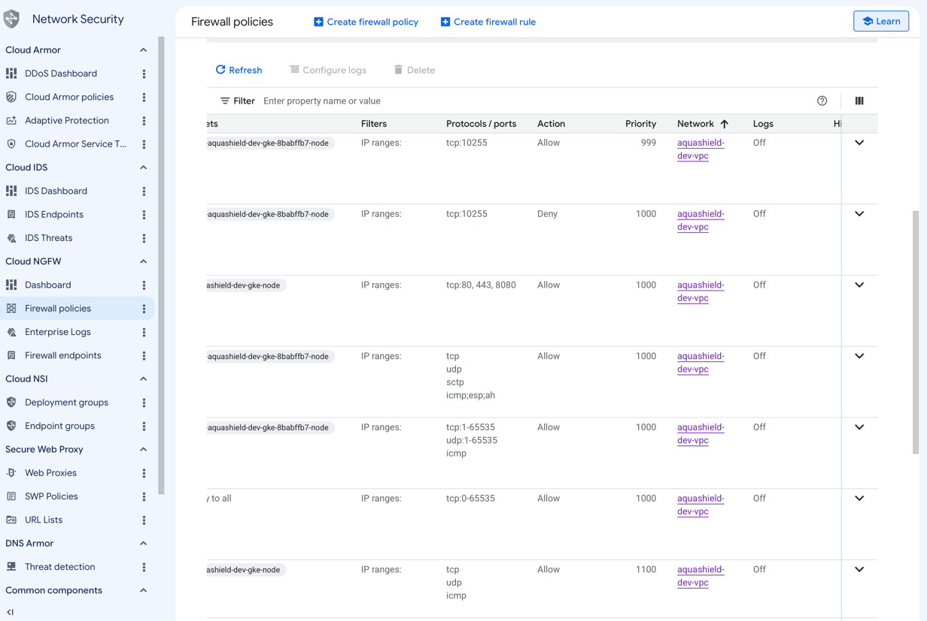

AWS IoT Rule Triggering the Lambda Bridge for Telemetry Ingestion

